CLIVAR A10 Update Thursday October 20, 2011

Druffel Group, University of California-Irvine

Alysha Coppola, Ellen R.M. Druffel and Sheila Griffin

In addition to the repeated measurements along the 30oS transect from Cape Town to Rio de Janeiro, the Druffel group has had the exciting opportunity during the CLIVAR A10 cruise to collect water for dissolved organic carbon (DOC), dissolved inorganic carbon (DIC) and Black Carbon (BC, char or soot) measurements to understand the complexities of the DOC pool using radiocarbon (14C) measurements. Radiocarbon in DOC must be measured in all major ocean basins to understand the timescale of DOC cycling and water mass transport in the deep sea.  Only 5 locations have been measured for DOC 14C in the world ocean, and our participation in this cruise will provide the first 3 profiles for the South Atlantic.  We are measuring DIC 14C to determine of the mixing time of seawater.

Dissolved Organic Carbon is the largest exchangeable pool of organic carbon in the ocean (662 Pg C; Hansell et al., 2009). Marine DOC is homogeneous and is operationally defined as the material that passes a 1 to 0.2 μm filter. Although DOC contains as much carbon as the atmosphere, this carbon pool is largely uncharacterized. Most intriguing however, is the mystery of the old 14C-age of DOC.

 The Druffel group’s participation in CLIVAR seeks to explain why this DOC pool is cycled on multi-millennial time scales, surviving through several ocean circulation cycles. The majority of marine organic carbon is produced from photosynthesis in the surface waters, so one would expect the DIC (CO2, H2CO3, HCO3-, CO32-) 14C in the surface waters to have the greatest influence on 14C content of DOC. However, this is not the case. The average radiocarbon age of DOC in the deep ocean ranges from 4,000-6,500 14C years old (Beaupre and Druffel, 2009) and is significantly older than DIC (700-2,400 14C years) (Beaupre and Druffel, 2009)(Figure 1). Interestingly enough, given the complex homogenous nature of DOC, it can be described by two-components; a modern, liable component and an older, more inert fraction.

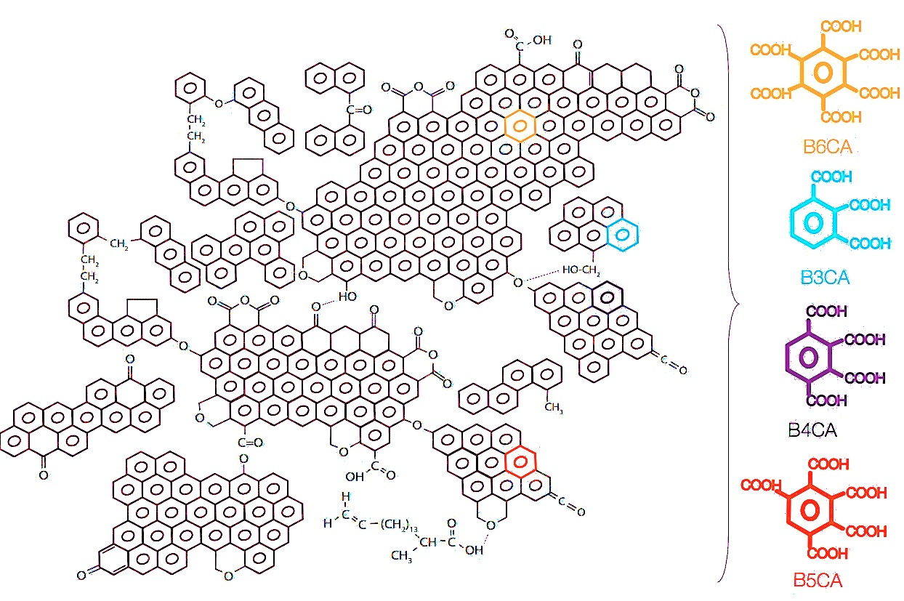 The presence of black carbon (BC) in marine DOC may be a key to understanding the old 14C age of DOC. Black carbon is produced from the incomplete combustion of fossil fuels and biomass, resulting in a continuum ranging from slightly charred plant material to soot. Black carbon is relatively inert, due to its condensed structure of benzene rings with few functional side groups (Figure 2). There is a large imbalance in the BC budget because the known sources are larger than the known sinks. Masiello and Druffel measured the BC content in NE Pacific sediments and discovered that BC was 2,400 ± 120 to 5,400 ± 520 14C yrs older than non-BC sedimentary organic carbon (SOC). If BC did not cycle in an intermediate pool before deposition, it would have the same age as the surrounding SOC. In order to explain the offset, they suggested that a pool of BC resides in an intermediate reservoir, namely marine DOC. Previous work by Ziolkowski and Druffel (2010) measured BC in dissolved organic matter, providing further motivation to investigate the entire DOC pool. The samples collected during the CLIVAR A10 Cruise will be the first measurements of BC in the marine entire DOC pool.

Figure 1. Δ14C of DOC and DIC as a function of depth in the Southern Ocean, North Central Pacific and in the Sargasso Sea (Druffel and Bauer, 2000)

Figure 2. Proposed structure of BC (Goldberg, 1985)

We have collected large quantities of water from three sites; Station 35 (1.63oW), Station 75 (13.71oW) and at the Mid-Atlantic Ridge (23.48oW) (Figure 3). DI14C data from the 2002 WOCE cruise are available near 2 of these stations to allow us to see the penetration of bomb 14C into the water column. Samples for BC analysis are collected close to the ridge axis to test for a possible source of BC-like compounds. For BC measurements, 25L at the surface and 50 L at depth are needed to provide enough carbon for 14C measurements. We will use solid phase extraction to concentrate DOC, with no molecular weight cut-offs. Then, we will use the Benzene Polycarboxylic Acid Method developed by Ziolkowski (2009) to isolate BC, by essentially exposing DOC to high temperature, pressure and nitric acid to oxidize non-BC material. We will measure 14C/12C ratios at the UCI Keck Carbon Cycle AMS Laboratory.



CLIVAR A10 has some great advances in store for understanding the DOC pool. In 2003, the CLIVAR Repeat Hydrography projects provided the first high-precision, high-resolution global view of DOC distribution. Craig Carlson is now further enhancing our global view of DOC on this cruise by collecting samples to measure DOC concentration at every degree to provide a more accurate representation of the South Atlantic. The Druffel lab will be providing the first measurements of BC in the entire DOC pool, and the first profiles in the South Atlantic. With CLIVAR A10, we will answer major questions about one of the largest reservoirs of carbon on Earth, of which we know surprisingly little about.

Figure 3. Our sites for DOC, BC and DIC 14Cmeasurements

Bauer, J., Druffel, E., Wolgast, D, Griffin, S., 2002. Temporal and regional variability in sources and cycling of

DOC and POC in the northwest Atlantic continental shelf and slope. Deep-Sea Research II 49 (20),

4387–4419.

Beaupre, S. and Druffel, E., 2009. Constraining the propagation of bomb-radiocarbon hrough dissolved

organic carbon pool in the northeast Pacific Ocean. Deep SeaResearch.

Goldberg, E.D. Black Carbon in the Environment: Properties and Distribution; Wiley: New York,

NY, USA, 1985; p.198.

Hansell, D.A., Carlson, C.A., 1998. Deep-ocean gradients in the concentration of dissolved organic carbon.

Nature 395 (6699), 263–266. Hansell, D.A., Carlson, C.A., 2009. Hansell/Carlson DOM Data

Collection,WOCE/CLIVAR Repeat Hydrography, PO2.

Ziolkowski, L., 2009. Radiocarbon of Black Carbon in Marine Dissolved Organic Carbon.Doctoral Thesis, U.C.

Irvine, Irvine, 117 pp.

Ziolkowski, L., and E. Druffel, 2010. Aged black carbon identified in marine dissolved organic carbon, Geophys. Res. Lett., 37, L16601, doi:10.1029/2010GL043963.